SHERIFF FOR ROODEPOORT

EXECUTION SALES

Held without prejudice

SALE DATE: 24 AUGUST 2018

AT

10H00

AT

182 PROGRESS ROAD, LINDHAVEN, ROODEPOORT

TEL: 760-1172

CONTACT: CHANTALLE McGOWAN – chantalle@sheroot.co.za

PROSPECTIVE BUYERS HAVE TO REGISTER ON THE DAY OF SALE (REGISTRATIONS STARTS
AT 09:30) AND PAY A DEPOSIT OF R2000.00 (CASH) WHICH IS REFUNDABLE.

REGISTRATION CLOSES PRECISELY AT 10:00 NO LATE REGISTRATIONS.


INTERNET BANKING AVAILABLE AT THIS OFFICE (PLEASE MAKE SURE OF YOUR DAILY LIMIT)
NO PERSONAL CHEQUES ACCEPTED ONLY BANK CHEQUES
WEB-SITE ADDRESS: www.sheroot.co.za

Summary of Conditions of Sale:

- Purchaser to pay a DEPOSIT OF 10% of the Purchase Price and the AUCTIONEERS COMMISSION (6% first R100 000, 3.5% on R100 001.00 to R400 000.00 & 1.5% on the balance of the proceeds of the sale max R40 000.00) & minimum R3 000.00 plus 14% V.A.T. on Commission in CASH or in form of a BANK CHEQUE, or EFT from our offices, immediately on the closing of the bid.
- Proof of residence, copy of ID required on day of sale. Power of Attorney if bidding on behalf of someone. Company Registration documents & Power of Attorney required if buying in a Company’s name.
- The Balance of the Purchase Price against transfer of the Property to be secured by a Bank of Building society guarantee, to be furnished within 14 - 21 Days after date of sale.
- The Purchaser is responsible for the Payment of the Outstanding RATES and LEVIES.
- If the Debtor is registered in terms of the VAT Act, VAT is payable on the Purchase Price, then no Transfer Duty is payable.
- Purchaser is Responsible for the EJECTMENT of the occupier.
- The information regarding the Description of the Property’s, Rates & Taxes and Levies is not GUARANTEED.
- NO AUCTIONEERS COMMISSION WILL BE REFUNDED UNDER ANY CIRCUMSTANCES AFTEr A SALE.

NO: | DEFENDANT | ADDRESS | DESCRIPTION
1. | 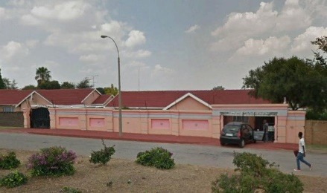 | Erf 37 Horizon View  44 Douglas Street | Lounge, TV-Livingroom, 2 Bathrooms, 3 Bedrooms, Kitchen, 2 Garages, Carport. 991m².
2. | 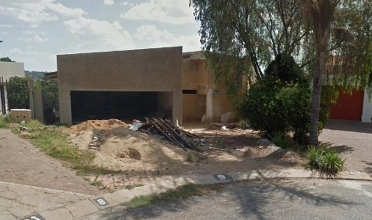 | Erf 1209 Roodekrans ext 7  9 Mint Avenue | Half Built Property. 1097m²
3. |  | Ptn 7 of Erf 948 Strubensvallei ext 9  7 Mandelieu, Cnr Elsie & Fiddle Str | Lounge, Family Room, Dining Room, 2 Bathrooms, 3 Bedrooms, Kitchen, Scullery/Laundry, 2 Garages, S/Pool, Lapa. 454m².
4. | 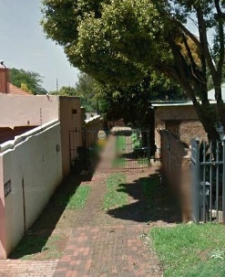 | Erf 557 Florida Glen ext 8  44A Rose Street | Lounge, Tv-Livingroom, 3 Bedrooms, 2 Bathrooms, Dining Room, Kitchen, 2 Garages. 554m².
5. | 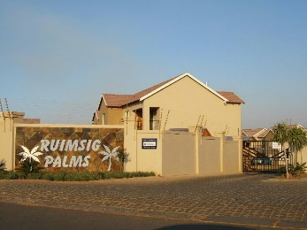 | Sect 5 Ruimsig Palms, Cabernet St, Willowbrook ext 18 | Lounge, Bathroom, 2 Bedrooms, Kitchen, Carport. 54m²
6. | 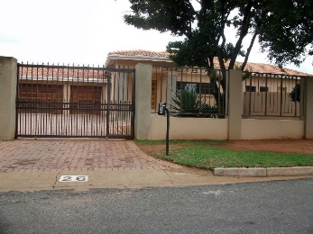 | Erf 1738 Florida ext 3  26 Parklane Avenue | Lounge, Family Room, Dining Room, 2 Bathrooms, 3 Bedrooms, Kitchen, Servants Quarters, 2 Garages. 1348m²
7. | 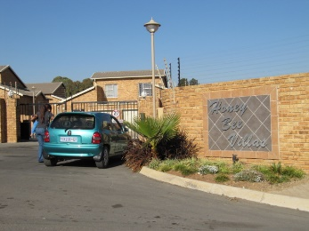 | Sect 20 HoneyBee Villas, Colleen St, HoneyPark ext 10 | Lounge, Bathroom, 2 Bedrooms, Kitchen, Carport. 87m²
8. | 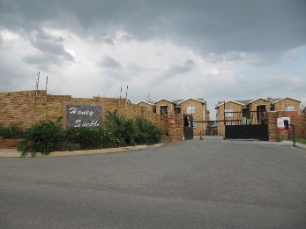 | Sect 72 Honey Suckle, Glover St, HoneyPark ext 10 | Lounge, 2 Bathrooms, 3 Bedrooms, Kitchen, 2 Garages. 93m²
9. | 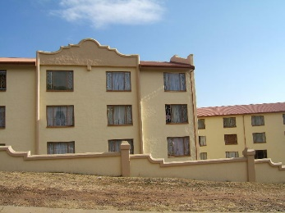 | Sect 38 & 22 Boschendal (Door 18)  2 Mirage Avenue, Helderkruin ext 1 | TV-Livingroom, Bathroom, 2 Bedrooms, Kitchen & Garage. 62 & 20 m².

RULES OF SALES IN EXECUTION CONDUCTED BY THE SHERIFF OF ROODEPOORT AS PRESCRIBED IN TERMS OF THE CONSUMER PROTECTION ACT OF 2008. (ACT NO. 68 OF 2008) AND THE REGULATIONS GOVERNING THE ACT

(Published in Government Gazette 34180 dated 1st April 2011)

Rules of the Sale in Execution Conducted by the Sheriff Roodepoort

- This Sale in Execution is conducted in terms of various Warrants of Execution issued by Courts in the Republic of South Africa and shall comply with the relevant Court Rules. Either moveable or immovable property is offered for sale to the highest bidder.
- The sale in Execution will take place at the Sheriff’s Office at 182 Progress Road, Lindhaven, Roodepoort at 10h00.
- This is to certify that I, Frederik Wilhelm Johannes Coetzee, ID Number 000000 0000 00 0, am duly appointed as Sheriff for Roodepoort, in terms of Section 2 of the Sheriffs Act. (Act 90 of 1986) It is further certified that I have a Trust Account into which all monies realized during the Sale in Execution, will be deposited. (The said Trust Account was opened in terms of Section 22 of the Sheriffs Act.) The only fees and commission to be deducted from this amount are as prescribed in the applicable tariff and/or rules of court.
- The goods put up for sale in execution, movable or immovable, are put up for sale by public auction in lots. Each lot is, unless there is evidence to the contrary, regarded to be the subject of a separate transaction.
- The sale in execution will commence at the advertised time and shall not be delayed to enable any person or persons not yet present to take part in the Sale in Execution. (Section 21(2) (f).
- All persons who intend to bid at the Sale in Execution shall register prior to the commencement of the Sale as contemplated in regulation 26(2). No unregistered bidders shall be allowed to bid. Regulation (28(2)). Please see “Bidders Record” herewith for registration requirements.
- Should any person attending the Sale in Execution intend to bid on behalf of another person, an original letter of authority shall be handed to the Sheriff. The letter needs to meet the requirements of regulation 26(3) in order to so bid on behalf of that person.
- All Bidders records as contemplated in regulation 26 and the vendu roll contemplated in regulation 28(4) will be available for inspection during normal office hours, without the charge of a fee and will contain a breakdown of the total cost of advertising, if any, and other costs for conducting the Sale in Execution and a statement indicating whether additional costs may be added and if so, how such costs will be computed.
- The rules for Sales in Execution conducted by the Sheriff are in accordance with the requirements of regulation 21. These rules will not be read out prior to the sale in execution but will be available for inspection at my office during normal office hours. These rules will be available at least 24 hours prior to the commencement of the Sale in Execution and will be printed on the sale Catalogue and lot listing.
- All movable goods offered for sale may be inspected at the address where the Sale in Execution is to take place 30 minutes prior to the commencement of the sale. In the event of the sale being the respect of Immovable Property in terms of a Warrant of Execution issued by a competent court, the Sheriff is unable to guarantee free inspection or viewing of the property offered for sale.
- Notwithstanding the fact that the sale is a public sale, the right of admission remains reserved in terms of Regulation 28(3).

Bidders Record (Regulation 26):

- The Sheriff shall for every auction have a Bidders record to record the identity of all bidders at a Sale in Execution
- Subject to regulation 30(2), the Sheriff shall ensure that every prospective bidder shall, prior to the commencement of any Sale in Execution, register his/her identity in the Bidders Record and such registration must, with the necessary changes, meet the requirements of Chapter 1 of the regulations in terms of the Financial Intelligence Centre Act, 2001, (FICA) published in Notice R.1595 in Gazette no 24176 of 20 December 2001, in respect of establishment and verification of identity, and sign that entry. (All buyers will require to produce to the Sheriff a copy of his/her ID Book as well as proof of residence as per an electricity or similar utility account not older than 3 months.)
- The Sheriff shall ensure that a person who intends to bid on behalf of others, produces a letter of authority expressly authorizing him/her to bid on behalf of that person/persons, and both that person and the person bidding on his/her behalf, must meet the requirements of sub-regulations (2) (FICA)
- The Sheriff shall ensure that, in the event of person bidding on behalf of a company, a letter of authority (Power of Attorney) contemplated in sub-regulation (3) printed on the letterhead of the company and accompanied by a certified copy of the resolution authorizing him/her to do so is filed together with the registration. (It is submitted that all Banks and their agents are included in this concept. Kindly file a copy of the said documentation prior to the commencement of each and every future Sale in Execution to enable the Sheriff to comply with paragraph 5 below.) No late registrations may be allowed as late registrations are prohibited by the regulations.
- No late registrations may be allowed as late registrations are prohibited by the regulations.
- A Sheriff shall record the bidders numbers contemplated in regulation 28(1) in the Bidders Record.
- The Bidders Record shall be available for public inspection in respect of the names of bidders and all the bidders numbers referred to in the sub-regulation 6 only, at any time, free of charge-

- During the Sale in Execution, at the premises where the Sale in Execution is being held; and
- After the Sale in Execution, at the place where the Sale in Execution took place or at :
- The Sheriff’s Office during normal office hours.

